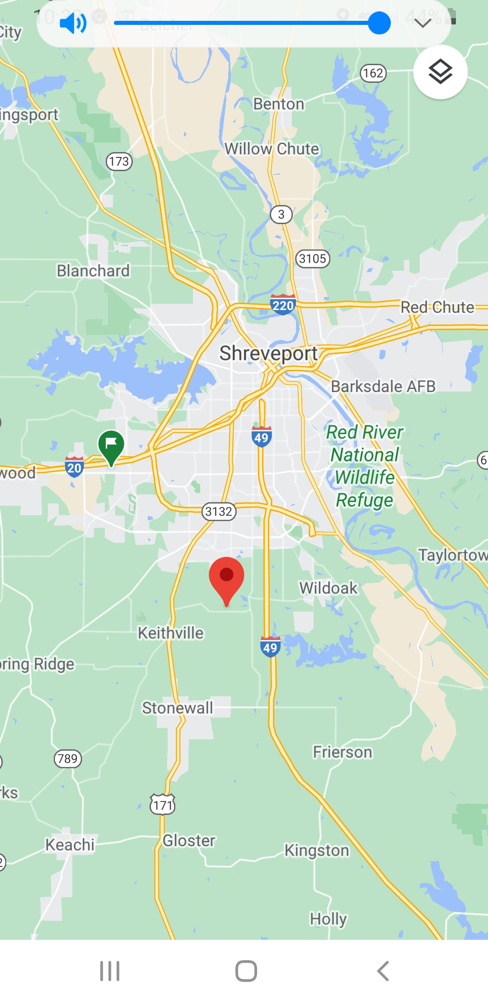

Barron Rd. Baptist Church

1102, Barron Rd.

Keithville, LA 71047